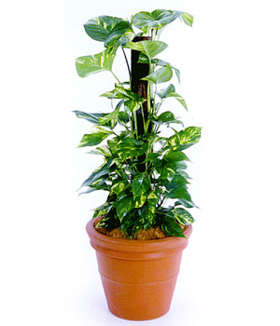
FOOD CHAIN Sentences
Make sentences about food chains using the following words:

Plants, food, producers.

_______________________________________________________________________________

_______________________________________________________________________________

_______________________________________________________________________________

Animals, energy, eaten.

____________________________________________________________________

____________________________________________________________________

____________________________________________________________________

Consumers, living, eat.

____________________________________________________________________

____________________________________________________________________

____________________________________________________________________
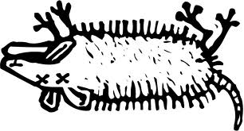
Decomposers, nutrients, dead.
____________________________________________________________________

____________________________________________________________________

____________________________________________________________________

Make your own sentence about food chains.

____________________________________________________________________

____________________________________________________________________

____________________________________________________________________

